

**Computer Science Department**

**COMP133 ( Spring 2023)**

**Project Phase Two *Due Date: Sat (17/6/2023) by 10:00 pm ( on Ritaj )***

**Notes:**

1. This project phase should be submitted by the due date and time ***( Late project phases will not be accepted for any reason ) on Ritaj.***

In this phase, you need to implement the major parts of the functions you created in phase one as follows:

***void displayMainMenu();*** // displays the main menu shown above

This function will remain similar to that in phase one with one minor addition which is the option:

***4- Print Book List***

***void addBook( int bins[], double prices[], int *size);***

This function will receive the arrays containing the bin numbers and the prices as parameters. It will also receive a pointer to an integer which references the current size of the list (number of books in the list).

The function will check to see if the list is not full. If list is not full ( size < MAXSIZE) then it will search for the appropriate position of a given bin number and if the bin number is already in the list it will display an error message. If not, the function will shift all the bins starting from the position of the new bin to the right of the array and then insert the new bin into that position. Same will be done to add the price of the book to the prices array.

***void removeBook(int bins[], double prices[], int *size);***

This function will receive the arrays containing the bin numbers and the prices as parameters. It will also receive a pointer to an integer which references the current size of the list (number of books in the list).

The function will check if the list is not empty. If it is not empty (size > 0) then it will search for the bin number to be removed and if not found will display an error message. If the bin number exists, the function will remove it and shift all the elements that follow it to the left of the array. Same will be done to remove the price of the book from the prices array.

***void searchForBook(int bins[], double prices[], int size);***

This function will receive the arrays containing the bin numbers and the prices as parameters. It will also receive an integer which has the value of the current size of the list (number of books in the list).

The function will check if the list is not empty. If it is not empty (size > 0) then it will ask the user to enter a bin number and will search for that bin number. If the bin number is not found it will display an error message.

If the bin number is found then it will be displayed along with the price in a suitable format on the screen.

***void uploadDataFile ( int bins[], int prices[], int *size );***

This function will receive the arrays containing the bin numbers and the prices as parameters. It will also receive a pointer to an integer which references the current size of the list (number of books in the list).

The function will open a file called ***books.txt*** for reading and will read all the book bin numbers and prices and store them in the arrays.

***void updateDataFile(int bins[], double prices[], int size);***

This function will receive the arrays containing the bin numbers and the prices as parameters. It will also receive an integer which has the value of the current size of the list (number of books in the list).

The function will open the file called ***books.txt*** for writing and will write all the book bin numbers and prices in the arrays to that file ( overwrite file ).

***void printBooks (int bins[], double prices[], int size); // NEW FUNCTION***

This function will receive the arrays containing the bin numbers and the prices as parameters. It will also receive an integer which has the value of the current size of the list (number of books in the list).

This function will print the information (bins and prices) currently stored in the arrays.

***Note: You need to define a constant called MAXSIZE ( max number of books stored) equal to 100.***

**VERY IMPORTANT:**

1. ***YOU MUST IMPLEMENT THE PROJECT USING PARALLEL ARRAYS EXACTLY AS SPECIFIED IN THE DESCRIPTION ABOVE. YOU MUST NOT USE ANY STRUCTURES. USING ANY STRUCTURES ANYWHERE IN YOUR PROJECT WILL RESULT IN YOU GETTING A GRADE OF ZERO FOR THE WHOLE PROJECT PHASE.***
2. Turn in your project phase by ***replying to the course coordinator’s message*** on Ritaj and attaching your code file (***main.c***).
3. You must include your full name, student id number, and lecture + lab section numbers in a comment at the beginning of your ***main.c*** code file.

***SAMPLE RUN:***

Make sure your program works **very similar** to the following sample run:

***Assuming that at the beginning of the run file books.txt has the following information stored:***

1234 72.45

2345 25.20

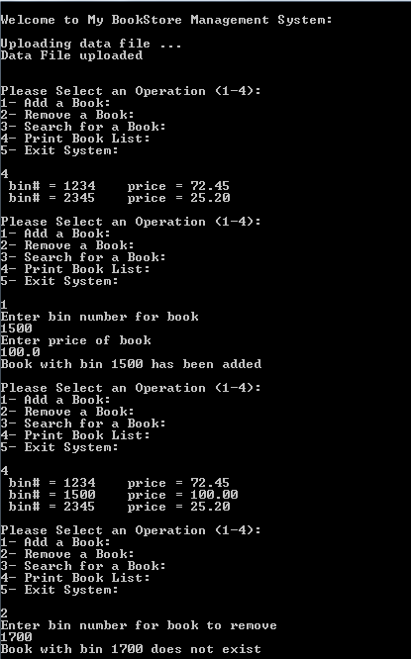

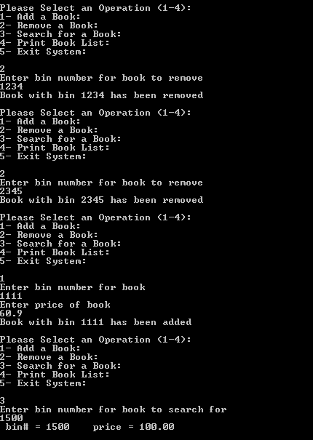

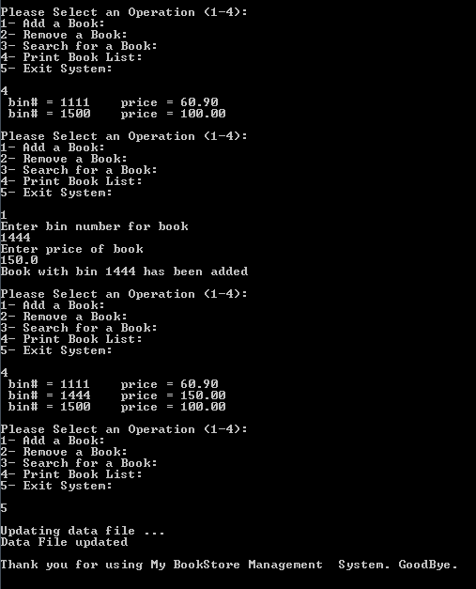

***Late project phases will not be accepted for any reason***.